|  |  |  |  |  |  |
| --- | --- | --- | --- | --- | --- |
| Date | 12-Dec-22 | | | Tester Name | Richard Belanger |
| Environment | Penfax - Test | | | Login used | TEST2 |
| Operating System | Windows | Version: | Update: | | |
| Software Used | Edge | Version: | Update: | | |
| Not Applicable | Version: | Update: | | |
| Release version | 22.4.1 | | | | |
| Title | M51.09 Disability Waiver Processing - Ad-hoc Batch | | | | |
| Test Type | Regression | | | | |
| Test Scenario | Run the Disability Waiver Processing Batch and verify to PENFAX | | | | |
|  |  | | | | |
| Expected Results | Disability Waiver Processing Batch runs and verified to PENFAX | | | | |
| Pass/Fail | Pass | | | JIRA# | N/A |

Describe your steps with screenshots:

Set up the batch

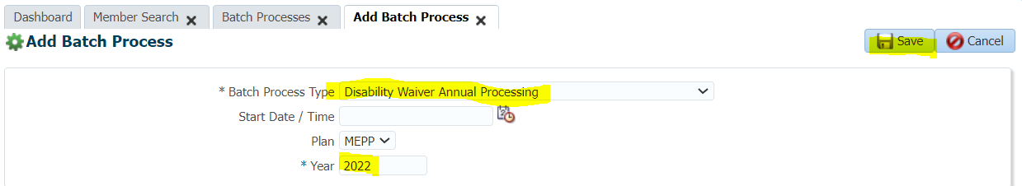

Succeeded

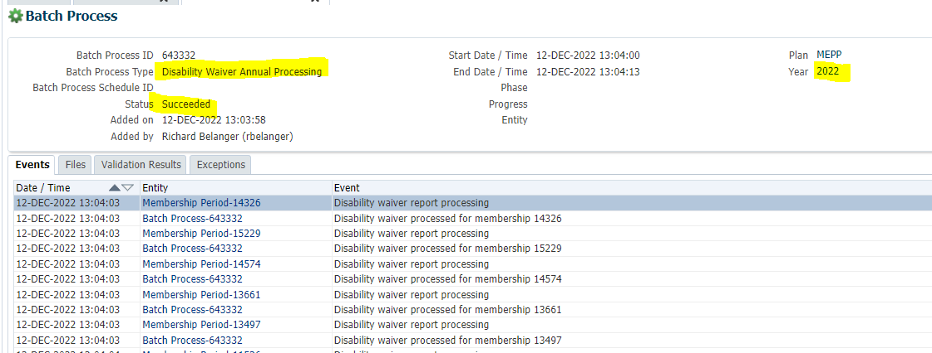

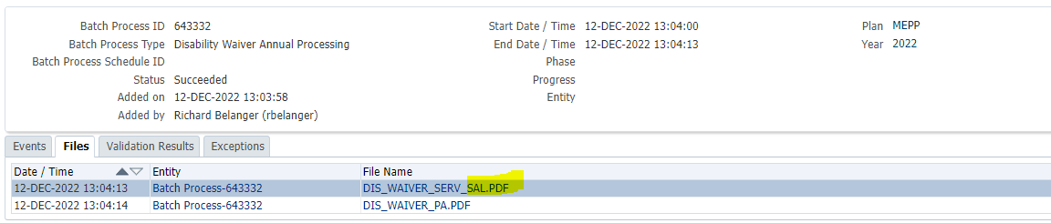

File saved to Testing Folder

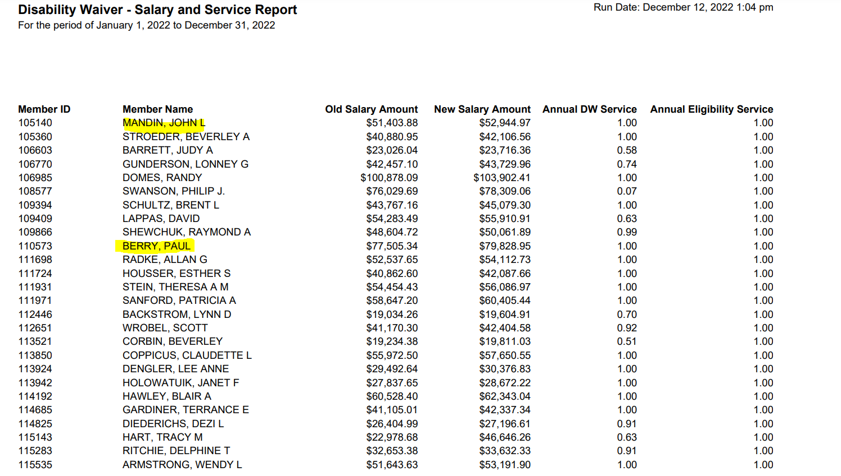

SID = 105140

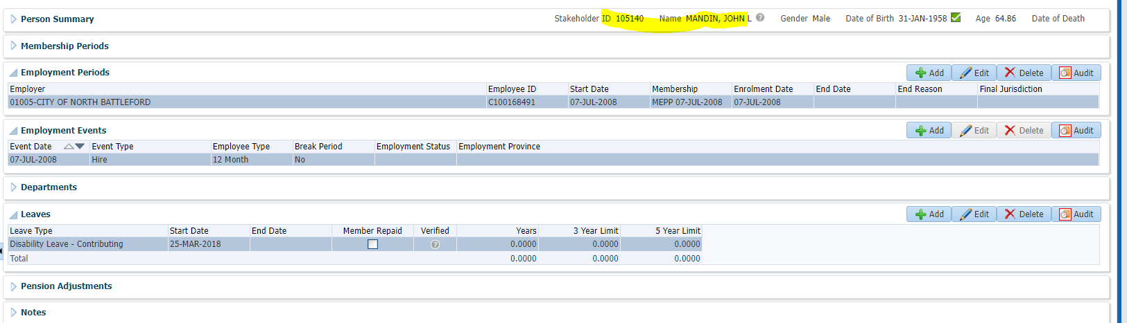

Payroll History

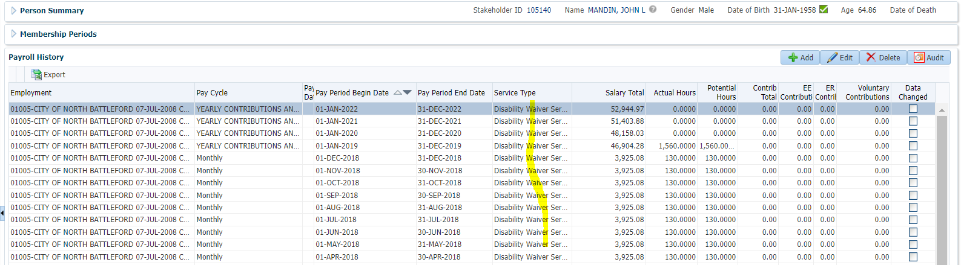

SID = 110573

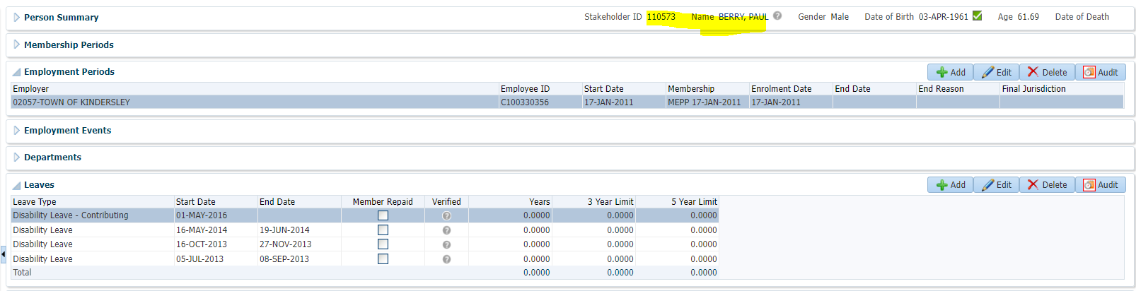

Payroll History

